**Logging using SLF4J**

**Exercise 2: Parameterized Logging**

**pom.xml**

<?xml version="1.0" encoding="UTF-8"?>

<project xmlns="http://maven.apache.org/POM/4.0.0"

         xmlns:xsi="http://www.w3.org/2001/XMLSchema-instance"

         xsi:schemaLocation="http://maven.apache.org/POM/4.0.0 http://maven.apache.org/xsd/maven-4.0.0.xsd">

    <modelVersion>4.0.0</modelVersion>

    <groupId>com.example</groupId>

    <artifactId>demo</artifactId>

    <version>1.0-SNAPSHOT</version>

    <properties>

        <maven.compiler.source>21</maven.compiler.source>

        <maven.compiler.target>21</maven.compiler.target>

    </properties>

    <dependencies>

        <dependency>

            <groupId>org.slf4j</groupId>

            <artifactId>slf4j-api</artifactId>

            <version>1.7.30</version>

        </dependency>

        <dependency>

            <groupId>ch.qos.logback</groupId>

            <artifactId>logback-classic</artifactId>

            <version>1.2.3</version>

        </dependency>

    </dependencies>

    <build>

        <plugins>

            <plugin>

                <groupId>org.codehaus.mojo</groupId>

                <artifactId>exec-maven-plugin</artifactId>

                <version>3.1.0</version>

                <configuration>

                    <mainClass>com.example.ParameterizedLoggingExample</mainClass>

                </configuration>

            </plugin>

        </plugins>

    </build>

</project>

**ParameterizedLoggingExample.java**

package com.example;

import org.slf4j.Logger;

import org.slf4j.LoggerFactory;

public class ParameterizedLoggingExample {

    private static final Logger logger = LoggerFactory.getLogger(ParameterizedLoggingExample.class);

    public static void main(String[] args) {

        String username = "Yashaswini";

        int userId = 123;

        String action = "logged in";

        logger.info("User {} with ID {} has {}", username, userId, action);

        logger.warn("Low disk space on server {} on {}","S1","2025-06-25");

        logger.error("Failed to capture request for user: {}", username);

    }

}

**Output:**

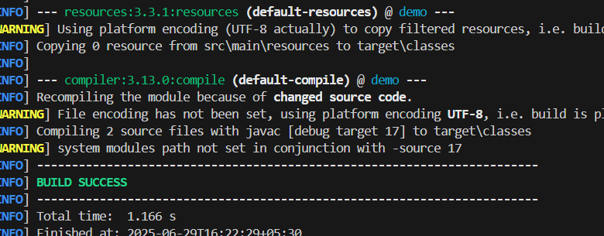

**____________________________________________________________________**

**Exercise 3: Using Different Appenders**

**pom.xml**

<?xml version="1.0" encoding="UTF-8"?>

<project xmlns="http://maven.apache.org/POM/4.0.0"

         xmlns:xsi="http://www.w3.org/2001/XMLSchema-instance"

         xsi:schemaLocation="http://maven.apache.org/POM/4.0.0 http://maven.apache.org/xsd/maven-4.0.0.xsd">

    <modelVersion>4.0.0</modelVersion>

    <groupId>com.example</groupId>

    <artifactId>demo</artifactId>

    <version>1.0-SNAPSHOT</version>

    <properties>

        <maven.compiler.source>21</maven.compiler.source>

        <maven.compiler.target>21</maven.compiler.target>

    </properties>

    <dependencies>

        <dependency>

            <groupId>org.slf4j</groupId>

            <artifactId>slf4j-api</artifactId>

            <version>1.7.30</version>

        </dependency>

        <dependency>

            <groupId>ch.qos.logback</groupId>

            <artifactId>logback-classic</artifactId>

            <version>1.2.3</version>

        </dependency>

    </dependencies>

    <build>

        <plugins>

            <plugin>

                <groupId>org.codehaus.mojo</groupId>

                <artifactId>exec-maven-plugin</artifactId>

                <version>3.1.0</version>

                <executions>

                    <execution>

                        <goals>

                            <goal>java</goal>

                        </goals>

                    </execution>

                </executions>

            </plugin>

        </plugins>

    </build>

</project>

**Logback.xml**

<configuration>

    <appender name="console" class="ch.qos.logback.core.ConsoleAppender">

        <encoder>

            <pattern>%d{HH:mm:ss.SSS} [%thread] %-5level %logger{36} - %msg%n</pattern>

        </encoder>

    </appender>

    <appender name="file" class="ch.qos.logback.core.FileAppender">

        <file>logs/app.log</file>

        <append>true</append>

        <encoder>

            <pattern>%d{HH:mm:ss.SSS} [%thread] %-5level %logger{36} - %msg%n</pattern>

        </encoder>

    </appender>

    <root level="debug">

        <appender-ref ref="console" />

        <appender-ref ref="file" />

    </root>

</configuration>

**AppenderExample.java**

package com.example;

import org.slf4j.Logger;

import org.slf4j.LoggerFactory;

public class AppenderExample {

    private static final Logger logger = LoggerFactory.getLogger(AppenderExample.class);

    public static void main(String[] args) {

        logger.debug("Debugging application");

        logger.info("Application started");

        logger.warn("Low space warning");

        logger.error("Unable to connect to database");

    }

}

**Output:**

